PROGRAM
import cv2
image = cv2.imread("flower.jpg")
if image is None:
print("Image not found")
else:
cv2.imshow("Flower Image", image)
cv2.waitKey(0)
cv2.destroyAllWindows()
COMMANDS USED
To install OpenCV:
pip install opencv-python
To move to the Desktop:
cd Desktop
To enter the OpenCV folder:
cd opencv
To execute the Python program:
python image_processing.py
EXPLANATION OF THE PROGRAM
import cv2
This statement imports the OpenCV library into the Python program.
cv2.imread("flower.jpg")
This function reads the flower.jpg image from the current folder.
if image is None:
This condition checks whether the image was loaded successfully.
print("Image not found")
This statement displays an error message if the image cannot be found.
cv2.imshow("Flower Image", image)
This function displays the loaded image in a window with the title Flower Image.
cv2.waitKey(0)
This function waits until the user presses a keyboard key.
cv2.destroyAllWindows()
This function closes all OpenCV windows.
INPUT
The input to the program is the image file: 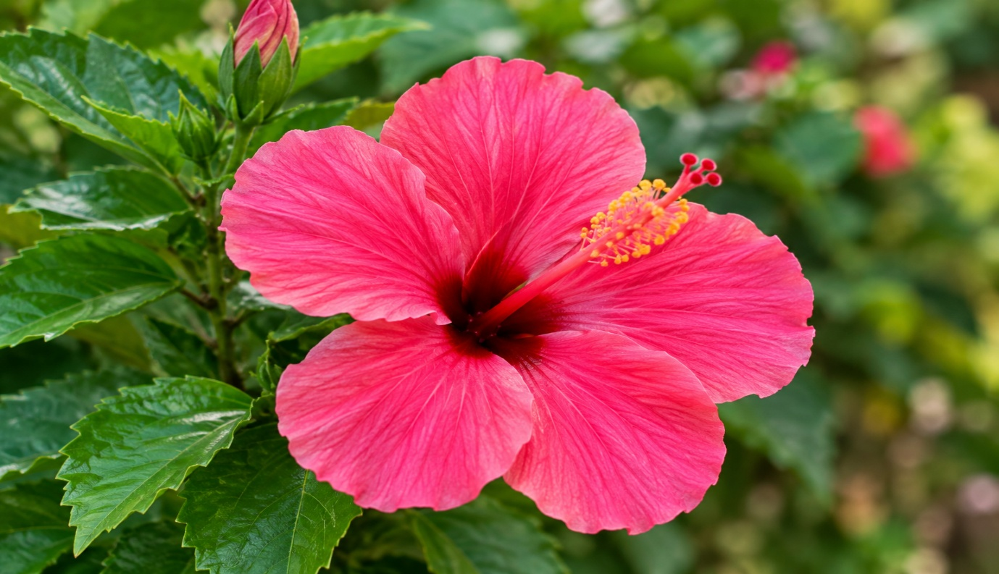
flower.jpg

OUTPUT
The flower.jpg image is successfully read using OpenCV and displayed in a separate window.
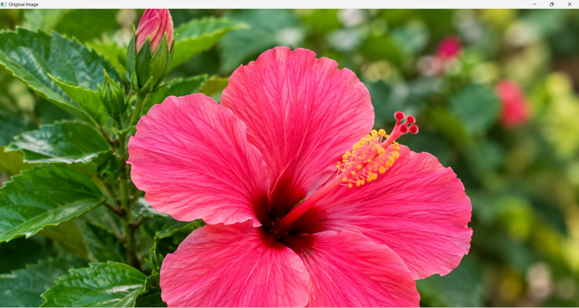
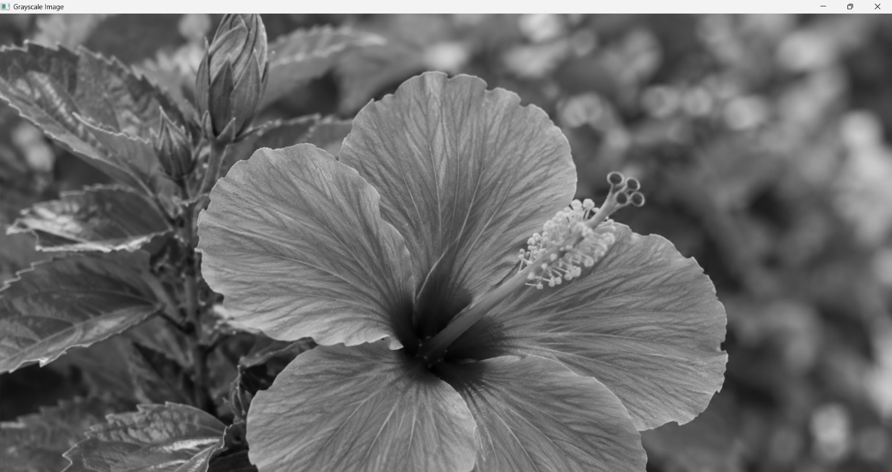
RESULT
Thus, the Python program for reading and displaying an image using OpenCV was successfully executed, and the flower.jpg image was displayed successfully.

